**Project 1:- E-learning Company Website Design**

**Index**

* 1. Registration…………………………………………………………………………………………. 2
  2. Login……………………………………………………………………………………………………6
  3. Homepage…………………………………………………………………………………………...9
  4. All Courses…………………………………………………………………………………………..15
  5. Detail Courses………………………………………………………………………………………20
  6. Courses Success…………………………………………………………………………………..25
  7. Learning room……………………………………………………………………………………… 27
  8. Dashboard……………………………………………………………………………………………32
  9. All Blog…………………………………………………………………………………………………37
  10. Detail Blog, Event…………………………………………………………………………………..42
  11. 404………………………………………………………………………………………………………47
  12. Overview of project 1 prototype………………………………………………………………..49
  13. **Registration**

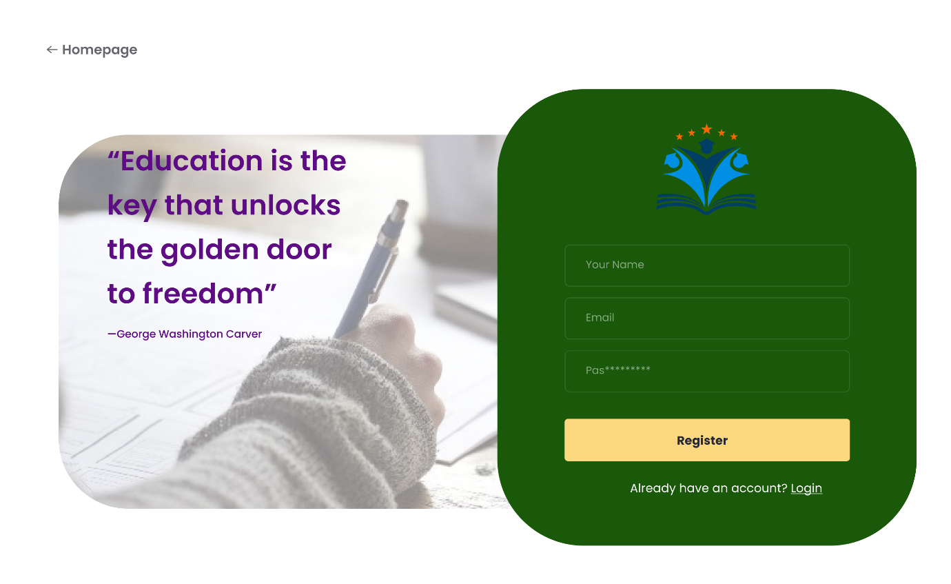

**Left Side:**

**Quote**:

* + - Text: "Education is the key that unlocks the golden door to freedom"
    - Attribution: —George Washington Carver

**Reasoning:**

* + - The inspirational quote by George Washington Carver serves to motivate and engage users right from the start.
    - Positioned prominently to capture attention and set a positive tone for the registration process.

**Typography**:

* + - Font: Poppins (Semi Bold)
    - Color: Purple (#5D0C83)
    - Size: Text (42) Attribution (16)

**Right Side:**

**Background Color**: Dark Green (#1A590A)

**Logo**:

* + - Positioned at the top center
    - Consists of a stylized book with blue pages and a person in the center, flanked by stars
    - Colors: Blue, Orange, dark blue

**Form Fields**:

* + - **Your Name**: Placeholder text in light grey within a rounded rectangle
    - **Email**: Placeholder text in light grey within a rounded rectangle
    - **Password**: Placeholder text in light grey (displayed as dots) within a rounded rectangle

**Reasoning:**

* Rounded rectangles are user-friendly and modern, making the input fields approachable and less intimidating.
* Light grey placeholders provide guidance without overwhelming the user, maintaining a clean look.

**Register Button**:

* + - **Color**: Light Yellow (#FCD980)
    - **Text**: "Register"

**Reasoning:**

* The light yellow color (contrasting with the dark green background) draws attention, making it clear where to click to submit the form.
* Positioning the button directly below the form fields follows a logical flow, leading users naturally from input to submission.

**Typography**:

* + - Font: Poppins
    - Color: Dark Green (#1A590A)
    - Style: Bold

**Login Link**:

* (“Already have an account? Login”)

**Reasoning:**

* Providing an option for existing users to log in ensures that returning users don't have to search for a login link, enhancing the user experience.
* The link is underlined to indicate interactivity, a common web convention for clickable links.
  + - **Typography**:
    - Font: Poppins
    - Color: White (#FFFFFF)
    - Underlined to indicate it’s a clickable link.

**Navigation:**

**Homepage Link**:

* + - Positioned at the top left
    - Text: "Homepage"

**Reasoning:**

* Placing the "Homepage" link in the top left corner is a common design practice, aligning with user expectations and providing an easy way to return to the main page.
* The left arrow icon indicates a navigation option to go back, enhancing usability.

**Typography**:

* + - Font: Poppins
    - Color: Light Grey (#282938)
    - Accompanied by a left arrow icon to indicate a back navigation

**General Design:**

**Color Palette**:

* + - Purple (#5D0C83) for the quote
    - Dark Green (#1A590A) for the background of the form and text on the button
    - Light Yellow ((#FCD980) for the register button
    - White (#FFFFFF) for the login link and form field text
    - Light Grey (#282938) for placeholders and homepage link

**Typography**:

* All text appears to be in a clean, Poppins font with varying weights and sizes to distinguish between headers, body text, and form fields.
* This design uses a balance of visual elements and a clear, engaging user interface for the registration page, focusing on educational themes and easy navigation.
  1. **Login**

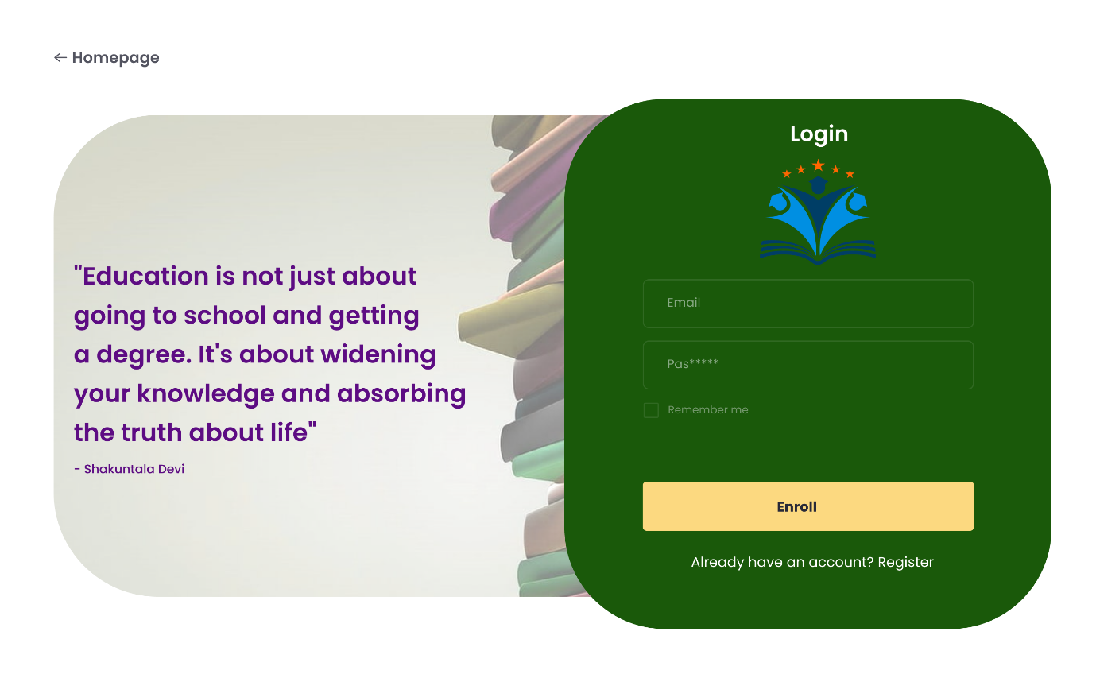

**Left Side:**

**Quote:**

* Text: "Education is not just about going to school and getting a degree. It's about widening your knowledge and absorbing the truth about life"
* Attribution: — Shakuntala Devi

**Reasoning:**

* The inspirational quote by Shakuntala Devi engages users, setting a positive and motivating tone for the login process.
* Positioned prominently to capture attention and emphasize the importance of education.

**Typography:**

* Font: Poppins
* Color: Purple (#5D0C83)
* Size: The quote text is larger, and the attribution is smaller.

**Right Side**:

* Background Color: Dark Green (#1A590A)

**Logo:**

* Positioned below the "Login" heading at the top center.
* Consists of a stylized book with blue pages and a person in the center, flanked by stars.
* Colors: Blue, Orange, Darkblue

**Typography:**

* Font: Poppins
* Color: White (#FFFFFF)
* Size: Larger than form field labels for emphasis.

Form Fields:

* Email: Placeholder text in light grey within a rounded rectangle.
* Password: Placeholder text in light grey (displayed as dots) within a rounded rectangle.
* Remember Me Checkbox: Small checkbox with "Remember me" text in light grey.

**Enroll Button:**

* Color: Light Yellow (#FCD980)
* Text: "Enroll"

**Typography:**

* Font: Poppins
* Color: Dark Green (#1A590A)

**Register Link:**

* (“Already have an account? Login”)

**Typography:**

* Font: Poppins
* Color: White (#FFFFFF)
* Underlined to indicate it’s a clickable link.
  1. 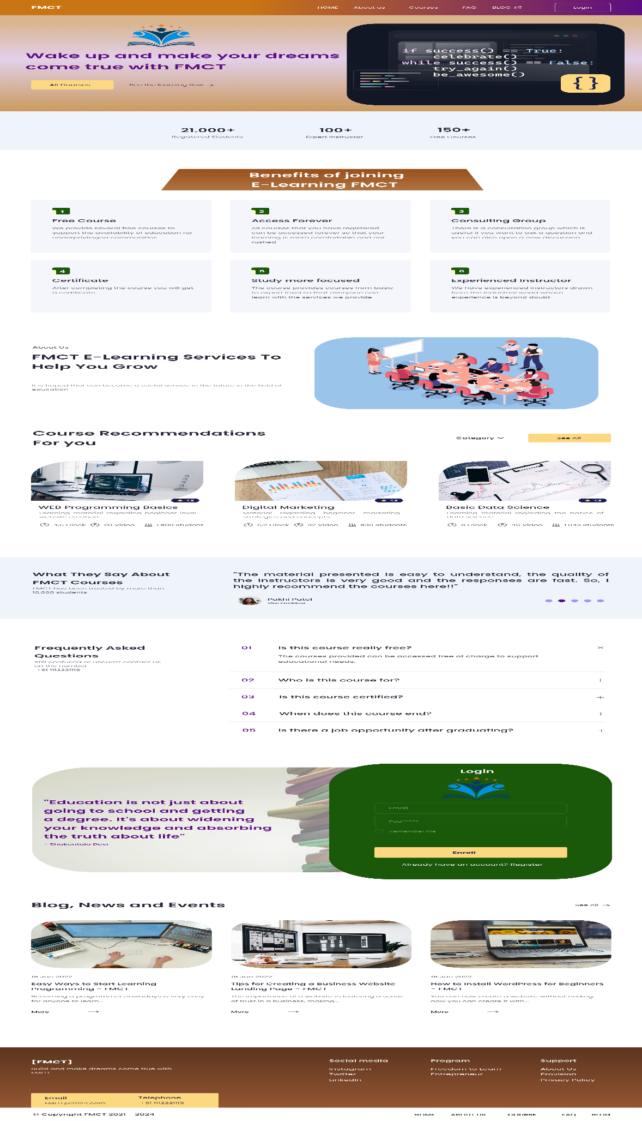**Homepage**

**Header**

**Top Bar:**

**Color:**

* Gradient from Orange (#C97514) to Purple (#5D0C83)

**Contains links:**

* FMCT logo, Home, About Us, Courses, Blog, Login.

**Typography:**

* Poppins, white text (#FFFFFF).

**Reasoning:**

* Provides immediate access to main sections (Home, About Us, Courses, Blog, Login).
* Consistent with user expectations for website navigation.
* The gradient background makes the header visually distinct.

**Hero Section**

**Left Side:**

**Text:**

* "Wake up and make your dreams come true with FMCT"

**Typography:**

* Font: Poppins
* Color: Purple (#5D0C83)
* Size: Large, bold for emphasis.

**Buttons:**

* "All Courses": Light Yellow button (#FCD980)
* "See the Learning Flow": Plain text link with arrow icon, purple text (#5D0C83).

**Reasoning:**

* Captures attention with a motivational message and a visual cue (image of code).
* Clear call-to-action buttons ("All Courses", "See the Learning Plan") guide users to explore the offerings.
* The large, bold typography emphasizes the main message.

**Right Side:**

* Image of a computer screen displaying a piece of code with an inspirational message.

**Code Text:**

* White text on a dark blue background.

**Statistics Section**

**Statistics:**

* "21,000+" Registered Students
* "100+" Expert Instructors
* "150+" Free Courses

**Typography:**

* Font: Poppins
* Color: Dark Grey (#F4F6FC)
* Size: Medium, with numbers in bold.

**Reasoning:**

* Provides social proof and credibility, encouraging trust in the platform.
* Visually breaks down important metrics that highlight the platform’s success.

**Benefits Section**

* Title: "Benefits of joining E-Learning FMCT"

**Typography:**

* Font: Poppins
* Color: Dark Orange (#853301)
* Size: Large, bold.

**Benefits:**

* Free Course, Access Forever, Consulting Group, Certification, Study More, Convenient Learning.
* Icons: Green squares with white icons.

**Reasoning:**

* Educates users about the advantages of joining FMCT.
* The use of icons and short descriptions makes the information easily digestible.

**About Us Section**

* Title: "FMCT E-Learning Services To Help You Grow"

**Typography:**

* Font: Sans-serif
* Color: Dark Grey (#232536)
* Size: Large, bold.

**Text:**

* Detailed description of FMCT's mission.

**Reasoning:**

* Provides detailed information about FMCT’s mission and values.
* The illustrative image adds a visual element that supports the text.

**Course Recommendations Section**

* Title: "Course Recommendations For you"

**Typography:**

* Font: :Poppins
* Color: Dark Grey (#282938)
* Size: Large, bold.

**Reasoning:**

* Personalizes the experience by suggesting specific courses.
* The visual design of the course cards is engaging and provides key details at a glance

**Courses:**

* Web Programming Basics,
* Digital Marketing,
* Basic Data Science.

**Cards:**

* Each course card includes an image, title, number of hours, views, and a tag for difficulty level.

**Typography:**

* Font: Poppins
* Color: Dark Grey (#282938) for text, with accents in blue (#1C1E53).

**Testimonials Section**

* Title: "What They Say About FMCT Courses"

**Typography:**

* Font: Poppins
* Color: Dark Grey (#282938)
* Size: Large, bold.

**Reasoning:**

* Showcases positive feedback from users, building credibility and trust.
* The slider format allows multiple testimonials to be featured in a compact spac

**FAQ Section**

* Title: "Frequently Asked Questions"

**Typography:**

* Font: Poppins
* Color: Dark Grey (#282938)
* Size: Large, bold.

**Reasoning:**

* Addresses common queries and concerns, reducing friction for new users.
* The accordion design keeps the section organized and easy to navigate.

**Questions:**

* A list of common questions with answers.

**Typography:**

* Font: Poppins
* Color: Medium Grey (#282938) for answers, with questions in dark grey (#282938).

**Login Section**

* Background: Dark Green (#1A590A)
* Quote: "Education is not just about going to school and getting a degree. It's about widening your knowledge and absorbing the truth about life" — Shakuntala Devi

**Typography:**

* Font: Poppins
* Color: Purple (#5D0C83)
* Size: Large, bold for the quote; smaller for the attribution.

**Reasoning:**

* Provides a convenient way for returning users to access their accounts.
* The use of a motivational quote reinforces the educational theme.

**Form:**

* Email and Password fields with placeholders.
* Remember me checkbox.
* Enroll Button: Light Yellow (#FCD980) with dark green text (#1A590A).
* Register Link: (“Already have an account? Login”) in white (#FFFFFF).

**Blog Section**

* Title: "Blog, News and Events"

**Typography:**

* Font: Poppins
* Color: Dark Grey (#282938)
* Size: Large, bold.

**Reasoning:**

* Keeps users engaged with additional content and updates.
* The blog cards are visually appealing and provide a summary to encourage clicks.

**Posts:**

* Easy Ways to Start Learning Programming, Tips for Creating a Business Website Landing Page, How to Install WordPress for Beginners.
* Cards: Each card includes an image, title, date, short description, and a link to read more.

**Typography:**

* Font: Poppins
* Color: Dark Grey (#282938) for text, with accents in blue (#282938).

**Footer**

* Background: Gradient from Brown (#53301C) to Dark Brown (#B96B3E)

**Reasoning:**

* Provides essential contact information and links to additional resources.
* The gradient background and organized layout ensure it is visually distinct but not overwhelming.

**Sections:**

* Contact Information: Email, Telephone.
* Social Media Links: Instagram, Twitter, LinkedIn.
* Program Links: Innovation, Leadership, Entrepreneurship.
* Support Links: About Us, FAQ, Privacy Policy.

**Typography:**

* Font: Poppins
* Color: White (#FFFFFF)
* Size: Small.
  1. **All Courses**

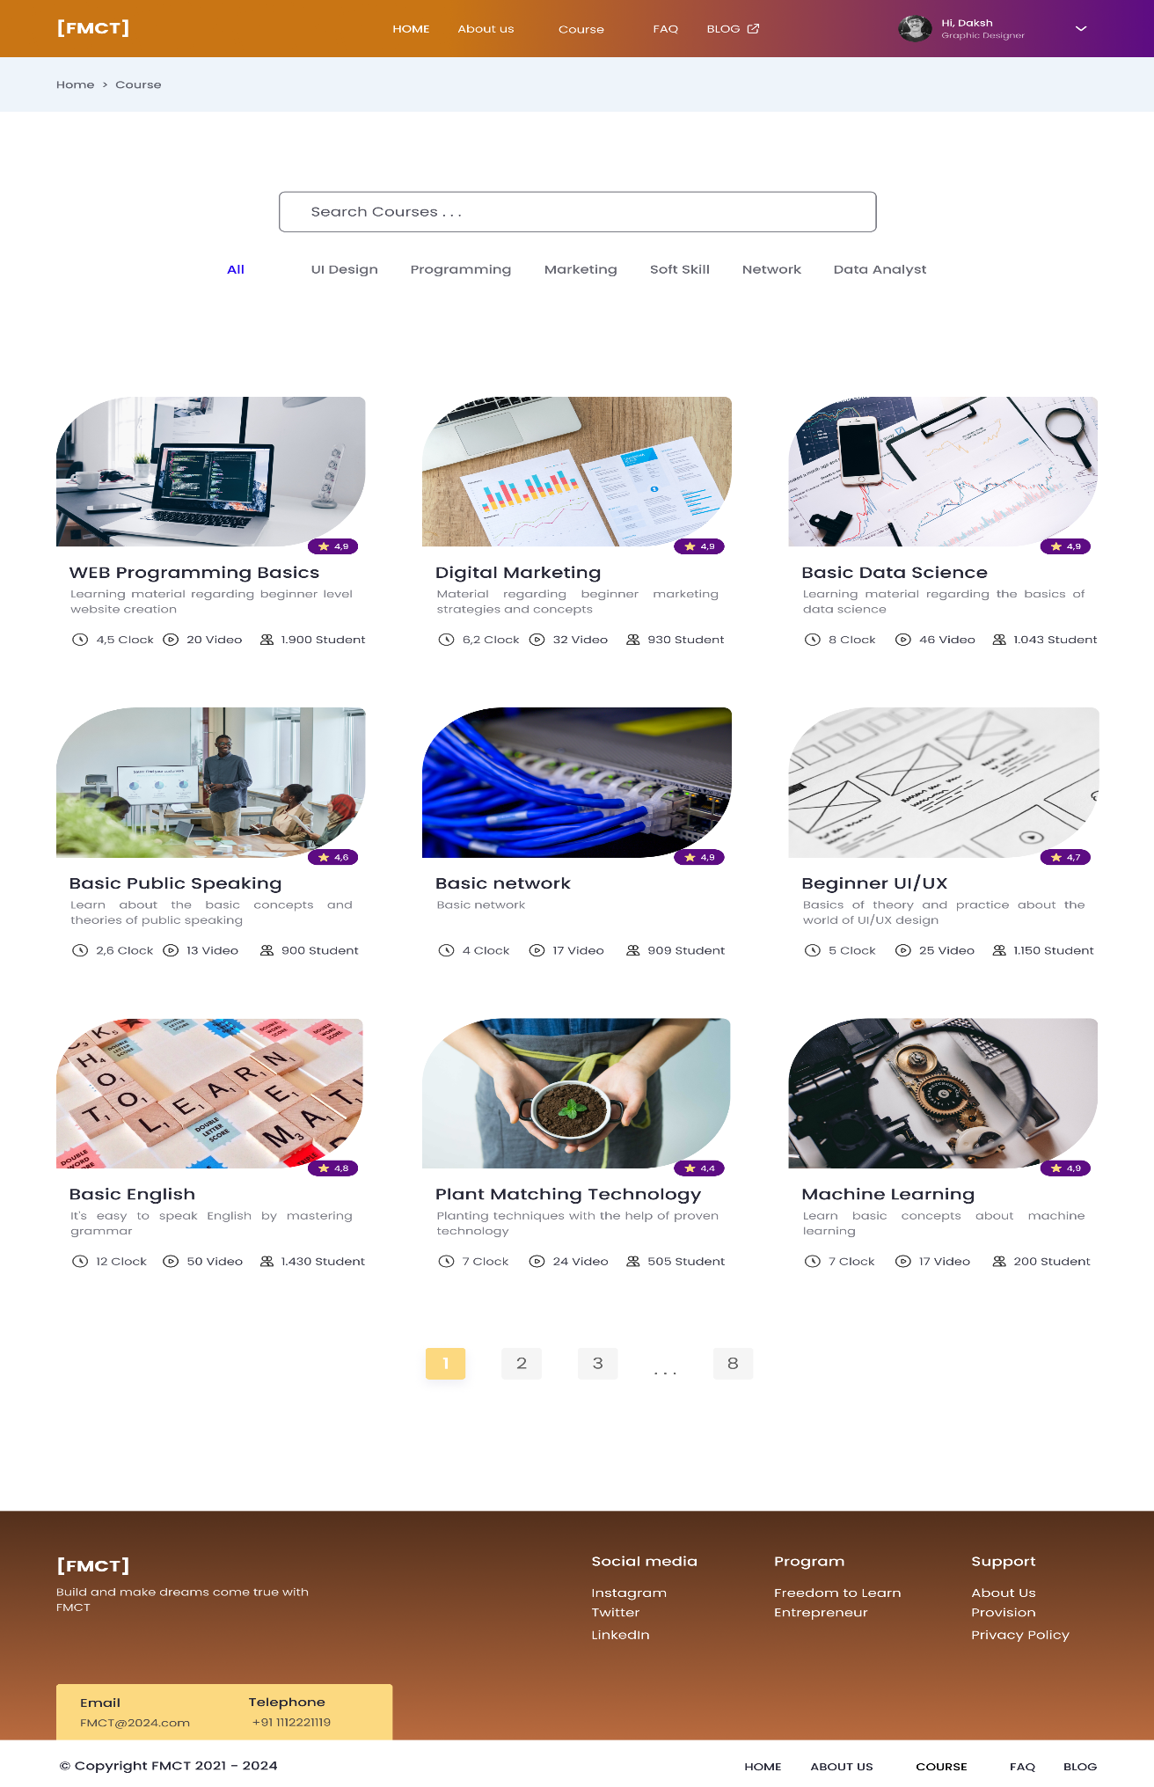

**Header**

**Top Bar:**

* Color: Gradient from Orange (#C97514) to Purple (#5D0C83)
* Contains links: FMCT logo, Home, About Us, Course, FAQ, Blog, Login/User Profile (Hi, Daksh - Graphic Designer).

**Typography:**

* Font: Poppins, white text (#FFFFFF).

**Reasoning:**

* Provides immediate access to main sections (Home, About Us, Course, FAQ, Blog, Login/User Profile).
* Consistent with user expectations for website navigation.
* The gradient background makes the header visually distinct, drawing attention.

**Search and Filter Section**

* Background: White (#FFFFFF)

**Search Bar:**

* Placeholder text: "Search Courses..."

**Typography:**

* Font: Poppins
* Color: Light Grey (#282938)

.

**Filter Tabs:**

* All, UI Design, Programming, Marketing, Soft Skill, Network, Data Analyst.

**Typography:**

* Font: Poppins
* Color: Dark Grey (#282938) for unselected, Blue (#2405F2) for selected (All).

**Reasoning:**

* The search bar allows users to quickly find specific courses.
* Filter tabs enable users to narrow down the course listings by category, improving usability and reducing the time needed to find relevant content.
* The design is clean and minimalistic, keeping the focus on search and filtering functionality

**Course Listing Section:**

* Background: White (#FFFFFF)

**Courses**:

* Each course card includes an image, title, brief description, rating, clock hours, number of videos, and number of students.

**Card Details:**

* Title: Dark Grey text (#282938), medium-bold.
* Description: Light Grey text (#282938), medium.
* Rating: Purple (#5D0C83) with white star icon.
* Clock, Video, Student Icons: Grey icons with accompanying text.

**Courses Listed:**

* WEB Programming Basics
* Digital Marketing
* Basic Data Science
* Basic Public Speaking
* Basic Network
* Beginner UI/UX
* Basic English
* Plant Matching Technology
* Machine Learning

**Reasoning:**

* Displays a grid of courses with relevant information (title, description, rating, clock hours, number of videos, and number of students).
* The consistent card design ensures that users can quickly scan and compare courses.
* Each course card includes visual elements (images) to make the content more engaging.
* The use of icons for clock hours, videos, and students adds clarity and helps in quick information assimilation.

**Pagination Section**

* Background: White (#FFFFFF)

**Pagination:**

* Pages: 1, 2, 3, ... 8.

**Current Page**:

* Yellow (#FCD980), white text (#FFFFFF).

**Other Pages:**

* Light Grey (#F5F5F5).

**Reasoning:**

* Allows users to navigate through multiple pages of courses easily.
* Highlights the current page in yellow, making it clear where the user is within the pagination.
* The light grey background and dark grey text for other pages maintain readability and usability.

**Footer:**

* Background: Gradient from Brown (#B96B3E) to Dark Brown (#53301C)

**Reasoning:**

* Provides essential contact information and links to social media, programs, and support resources.
* The gradient background and organized layout ensure it is visually distinct but not overwhelming.
* Footer links help users navigate to other important sections of the website without scrolling back to the top.

**Sections:**

**Contact Information:**

* Email: FMCT@2024.com
* Telephone: +91 1112221119
* Social Media Links: Instagram, Twitter, LinkedIn.
* Program Links: Freedom to Learn, Entrepreneur.
* Support Links: About Us, Provision, Privacy Policy.

**Typography:**

* Font: Poppins
* Color: White (#FFFFFF)
* Size: Small.
  1. **Detail Courses**

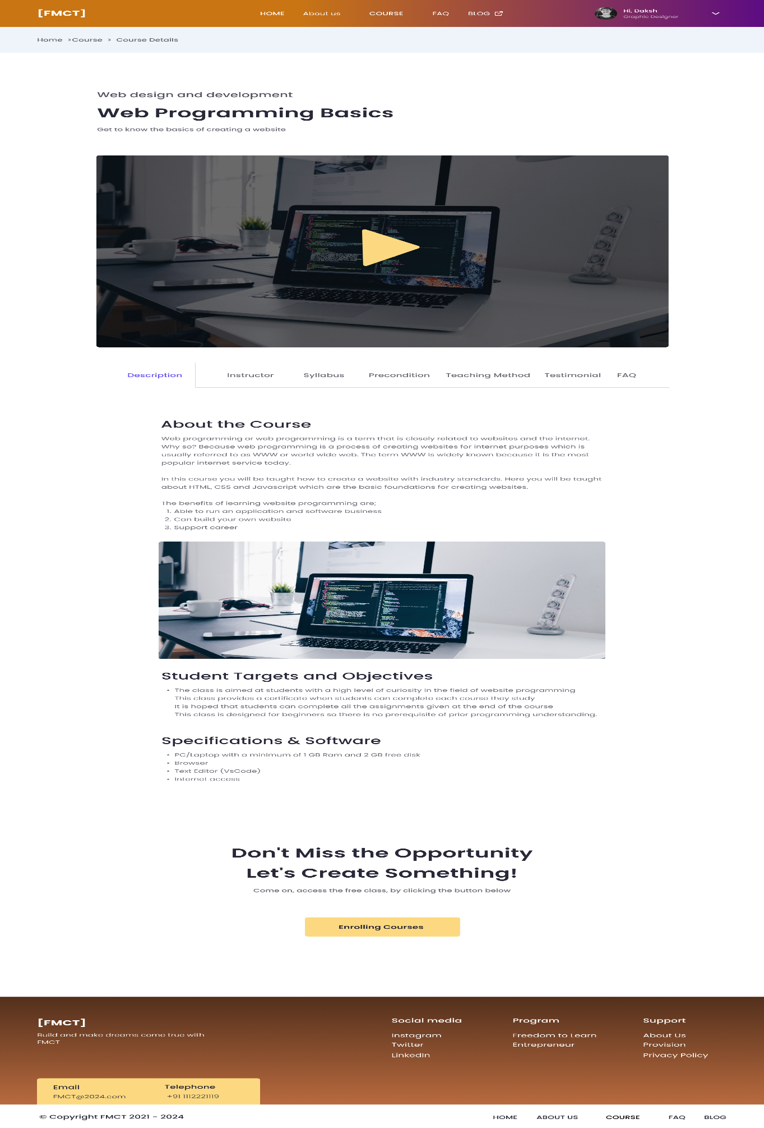

**Header**

**Top Bar:**

* Color: Gradient from Orange (#C97514) to Purple (#5D0C83)

**Contains links:**

* FMCT logo, Home, About Us, Course, FAQ, Blog, Login/User Profile (Hi, Daksh - Graphic Designer).

**Typography**:

* Font: Poppins, white text (#FFFFFF).

**Reasoning:**

* Provides immediate access to main sections (Home, About Us, Course, FAQ, Blog, Login/User Profile).
* Consistent with user expectations for website navigation.
* The gradient background makes the header visually distinct, drawing attention.

**Breadcrumb Navigation:**

* Text: "Home > Course > Course Details"
* Color: Light Blue background (#EEF4FA) with Dark Grey text (#282938).

**Typography:**

* Font: Poppins, medium size.

**Reasoning:**

* Helps users understand their current location within the website.
* Provides easy navigation back to previous sections (Home > Course).
* Light blue background with dark grey text ensures readability and visual separation from other elements.

**Course Title and Introduction:**

* Title: "Web Programming Basics"
* Sub-Title: "Web design and development"
* Description: "Get to know the basics of creating a website"

**Typography:**

* Title: Bold, Black text (#000000), large font size.
* Sub-Title: Medium, Grey text (#282938), smaller font size.
* Description: Medium, Light Grey text (#282938).

**Reasoning:**

* Immediately informs the user about the course they are viewing.
* Clear and prominent typography for the title ensures it stands out.
* Sub-title and description provide additional context about the course.

**Course Video:**

* Image: Laptop with code editor open
* Play Button: Yellow (#FCD980) triangle overlay
* Background: White (#FFFFFF).

**Reasoning:**

* Engages users with a visual representation of the course content.
* The yellow play button is prominent, encouraging users to interact.

**Tab Navigation:**

* Tabs: Description, Instructor, Syllabus, Precondition, Teaching Method, Testimonial, FAQ
* Active Tab: Blue text (#2405F2) for Description
* Inactive Tabs: Dark Grey text (#282938)

**Typography:**

* Font: Poppins, medium size.

**Reasoning:**

* Allows users to switch between different sections of course information without scrolling.
* Active tab is highlighted in blue, providing a clear indication of the current section.
* Keeps the page organized and information easily accessible.

**Course Content Section:**

**Description Section:**

* Heading: "About the Course"
* Text: Detailed description of the course, benefits, and learning outcomes.

**Typography:**

* Heading: Bold, Black text (#000000), large font size.
* Body: Medium, Dark Grey text (#282938), medium size.

**Student Targets and Objectives Section:**

* Heading: "Student Targets and Objectives"
* Text: Details on the target audience and course objectives.

**Typography**:

* Heading: Bold, Black text (#000000), large font size.
* Body: Medium, Dark Grey text (#282938), medium size.

**Specifications & Software Section:**

* Heading: "Specifications & Software"
* Text: Details on the technical requirements for the course.

**Typography:**

* Heading: Bold, Black text (#000000), large font size.
* Body: Medium, Dark Grey text (#282938), medium size.

**Reasoning:**

* Provides detailed information about the course in a structured manner.
* Each section has a clear heading and descriptive text, ensuring users can easily find the information they need.
* Typography and spacing are designed for readability.

**Call to Action**

**Section:**

* Text: "Don't Miss the Opportunity. Let's Create Something!"
* Button: "Enrolling Courses"
* Button Color: Yellow (#FCD980) with black text (#000000).

**Typography:**

* Heading: Bold, Black text (#000000), large font size.
* Body: Medium, Dark Grey text (#282938), medium size.
* Button: Bold, Black text (#000000).

**Reasoning:**

* Encourages users to enroll in the course with a clear and compelling message.
* The yellow button stands out against the white background, drawing attention to the enrollment action.
* The motivational text reinforces the value of the course.

**Footer**

* Background: Gradient from Brown (#B96B3E) to Dark Brown (#53301C)

**Reasoning:**

* Provides essential contact information and links to social media, programs, and support resources.
* The gradient background and organized layout ensure it is visually distinct but not overwhelming.
* Footer links help users navigate to other important sections of the website without scrolling back to the top.

**Sections:**

* Contact Information:
* Email: FMCT@2024.com
* Telephone: +91 1112221119
* Social Media Links: Instagram, Twitter, LinkedIn.
* Program Links: Freedom to Learn, Entrepreneur.
* Support Links: About Us, Provision, Privacy Policy.

**Typography:**

* Font: Poppins
* Color: White (#FFFFFF)
* Size: Small.
  1. **Courses Success**



**Content**

**Image:**

* The image of a happy person at the top captures user attention immediately, creating a positive emotional response.
* Image Shape: Rounded rectangle.

**Text:**

* Main Heading: "Happy! Your course is now open"
* Sub-Text: "The course you selected has been opened, please click the button below this"

**Button:**

* "Open Courses"

**Color Code**

* Background:
* White (#FFFFFF)

**Text Colors:**

* Main Heading: Dark Grey (#232536)
* Sub-Text: Light Grey (#535353)
* Button Text: Dark Grey (#232536)

**Button:**

* Background: Yellow (#FCD980)
* Text: Dark Grey (#282938)

**Typography**

Main Heading:

* Font: Poppins
* Weight: Bold
* Color: Dark Grey (#282938)
* Size: Large

**Sub-Text:**

* Font: Poppins
* Weight: Regular
* Color: Light Grey (#535353)
* Size: Medium

**Button:**

* Font: Poppins
* Weight: Bold
* Color: Dark Grey (#282938)
* Size: Medium
  1. **Learning room**

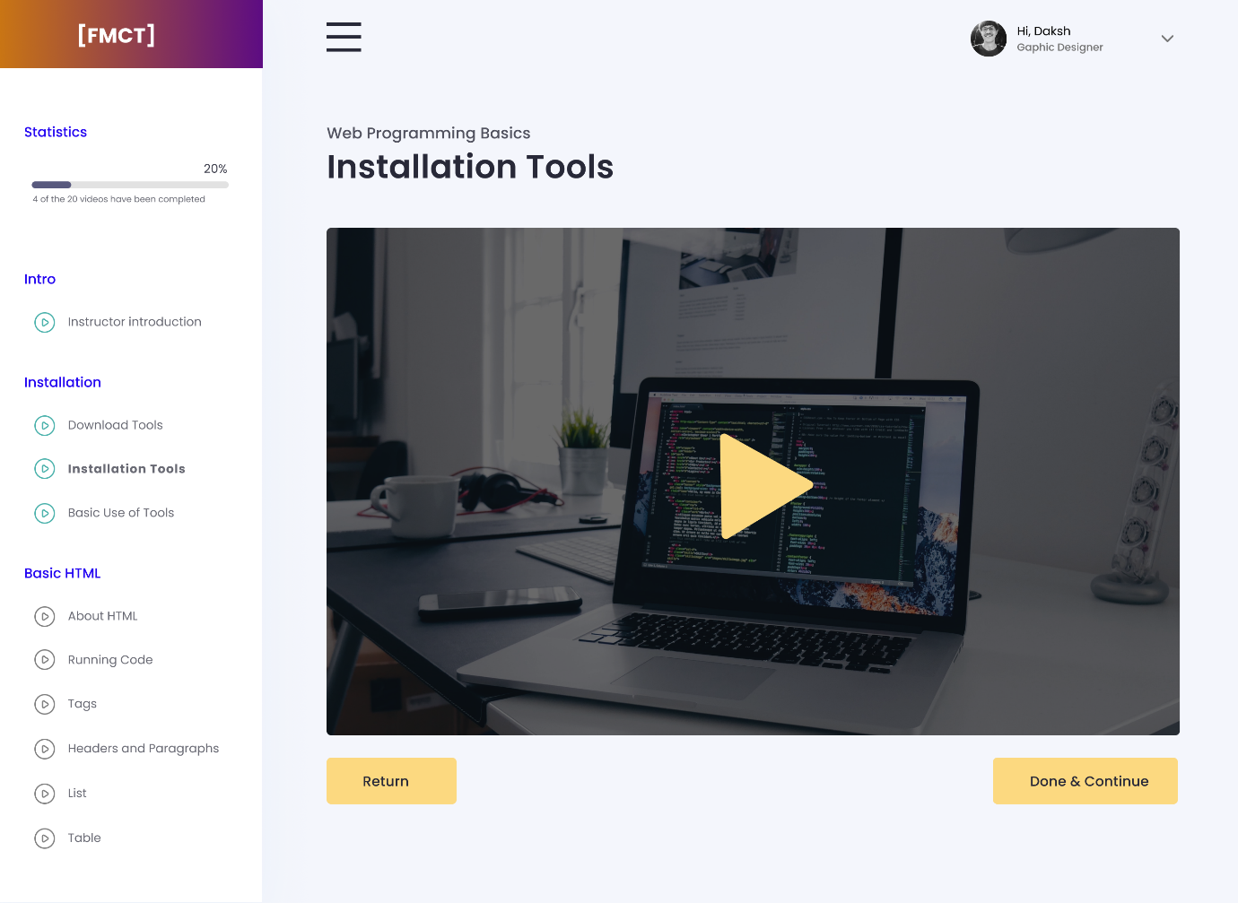

**Content:**

**Left Sidebar:**

* Logo: "[FMCT]" in white, on a gradient background from orange (#C97514) to purple (#5D0C83).

**Statistics Section:**

* Progress bar: 20% completion (4 of the 20 videos have been completed).
* Progress bar color: Blue (#1C1E53).
* Text: "Statistics" in blue (#1C1E53), percentage and details in grey (#282938).

**Course Sections:**

**Intro:**

* Instructor introduction (play icon).

**Installation:**

* Download Tools (play icon).
* Installation Tools (bold, currently selected, play icon).
* Basic Use of Tools (play icon).

**Basic HTML**:

* About HTML (play icon).
* Running Code (play icon).
* Tags (play icon).
* Headers and Paragraphs (play icon).
* List (play icon).
* Table (play icon).

**Main Content**

**Header**:

* "Web Programming Basics" in grey (#282938).
* "Installation Tools" in bold, black (#000000).

**Video Placeholder:**

* Image of a laptop with a code editor on the screen, overlayed with a large yellow play button.

**Buttons**:

* Return: Yellow (#FCD980), text in black (#000000).
* Done & Continue: Yellow (#FCD980), text in black (#000000).

**Top Navigation Bar:**

* Menu Icon: Hamburger menu (three horizontal lines) in black (#000000).

**User Profile:**

* "Hi, Daksh" in grey (#282938).
* "Graphic Designer" in grey (#282938).
* Profile picture placeholder.

**Primary Colors:**

* White (#FFFFFF).
* Blue (#2405F2).
* Grey (#282938).
* Black (#000000).
* Yellow (#FCD980).

**Typography**

Headers:

* Font: Poppins.
* Weight: Bold for course titles and selected items.
* Size: Large for main headers, medium for subheaders.
* Color: Grey (#282938) and Black (#000000).

**Body Text:**

* Font: Poppins.
* Weight: Regular.
* Size: Medium.
* Color: Grey (#282938).

**Buttons:**

* Font: Poppins.
* Weight: Bold.
* Size: Medium.
* Color: Black (#000000) on Yellow (#FCD980).

**Reasoning Behind the Design**

**Visual Hierarchy**

**Logo and Branding:**

* Placing the logo at the top-left ensures it is the first element the user sees, establishing brand identity immediately.
* The gradient background (orange to purple) behind the logo makes it stand out, reinforcing brand recognition.

**Statistics Section:**

* Positioned at the top of the sidebar to be one of the first elements noticed, providing immediate feedback on the user’s progress.
* The progress bar and percentage completion offer a quick visual cue about how much of the course has been completed, motivating users to continue.

**Course Sections:**

* Organized into clearly defined categories (Intro, Installation, Basic HTML) to help users navigate easily.
* Bold text for the active section ensures users always know where they are within the course content.

**Main Content Area**

**Header Information:**

* The course title and current lesson are placed at the top to orient the user immediately upon entering the page.
* Bold and larger text for the lesson title ("Installation Tools") ensures it is distinguishable from other text and catches the user's attention.

**Video Placeholder:**

* Central placement of the video placeholder draws focus to the primary learning material.
* The play button overlay on the video image indicates interactive content, prompting users to start the lesson.
* Buttons (Return and Done & Continue):
* Bright yellow buttons stand out against the white background, guiding users to the primary actions they can take.
* The "Return" button allows users to go back if needed, while "Done & Continue" encourages progression to the next part of the course.

**Navigation and User Experience**

**Sidebar Navigation:**

* Placed on the left for easy access and visibility, following common web design patterns that users are familiar with.
* The collapsible structure of the sidebar makes it easier to navigate between different sections without overwhelming the user with too much information at once.

**Progress Indicators:**

* The blue progress bar in the statistics section is visually distinct, providing a clear indication of progress.
* Specific progress details ("4 of the 20 videos have been completed") offer precise feedback, helping users track their learning journey.

**Top Navigation:**

* The hamburger menu in the top-right corner provides access to additional options without cluttering the main interface.
* User profile information adds a personal touch, making the user feel recognized and engaged.

**4. Color Scheme and Typography**

**Consistency:**

* Consistent use of specific colors for different elements helps users quickly understand the interface. Blue for statistics and yellow for action buttons create a visual language that users can easily follow.

**Readability:**

* Dark text on a light background improves readability, reducing eye strain and making content easy to digest.
* Bold headers and selected items provide clear visual cues, ensuring important information stands out.
  1. **Dashboard**

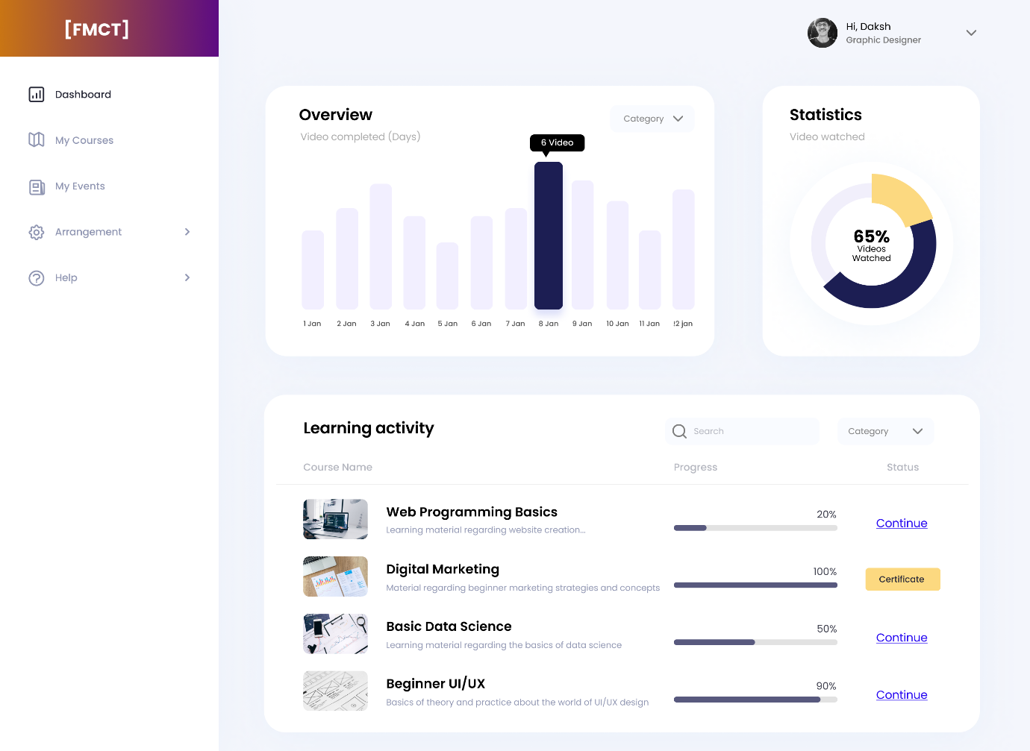

**Color Scheme:**

**Primary Colors:**

* Gradient in the logo area (top left) and header: Deep purple transitioning to orange (#5D0C83 to # C97514).
* Background: Light greyish blue (#F9FAFB).

**Text:**

* Black for primary text (#000000).
* Grey for secondary text (#9197B3).
* Graph Bars: Light purple (#F2EFFF) with a highlighted bar in dark purple (#1C1E53).
* Progress Bars: Different shades of blue and purple for progress visualization.
* Buttons and Labels: Blue for active states and continuation prompts, yellow for certificates.

**Typography:**

* Primary Font: Poppins, modern and clean, suitable for readability and professional appearance.
* Font Weight: Varies between normal and bold to differentiate headers, subheaders, and body text.

**User Flow and Navigation:**

**Sidebar Navigation (Left):**

* Dashboard: The main page where the user can see an overview of their progress.
* My Courses: Likely directs to a detailed view of all courses the user is enrolled in.
* My Events: Could include upcoming webinars, classes, or deadlines.
* Arrangement: Settings or organizational tools for the user.
* Help: Support or FAQ section.

**Main Content Area:**

**Overview Section (Top Left):**

* A bar graph displaying the number of videos completed over a series of days (1 Jan to 12 Jan). Each bar is light purple, with the highest bar on 8 Jan highlighted in dark purple and annotated with "6 Video".

**Statistics (Top Right):**

* A doughnut chart showing the percentage of videos watched, with a figure of 65% prominently displayed.

**Learning Activity (Bottom Section):**

**Course List:**

* Each course entry includes.
* Image: A small thumbnail representing the course.
* Course Name and Description: E.g., "Web Programming Basics" with a brief description underneath.
* Progress Bar: Visual representation of course completion percentage.
* Status: Actionable items like "Continue" or "Certificate" based on progress.

**Search and Filter:**

* Search Bar: Users can search for specific courses.
* Category Dropdown: Users can filter courses based on categories.
* Explanations for User Flow and Navigation Decisions

**Clear Hierarchy:**

* The design uses a clear visual hierarchy to guide the user's attention, starting with the sidebar for navigation, then the main content for detailed insights.
* High contrast between the sidebar and main content ensures easy differentiation.
* Progress and Achievement Focused:
* Emphasis on progress bars, percentages, and certificates keeps the user motivated and informed about their learning journey.
* Immediate access to continuation actions (e.g., "Continue" buttons) facilitates quick resumption of courses.

**Visual Feedback:**

* Use of colors to indicate progress and completion status provides immediate visual feedback.
* The bar graph and doughnut chart give a quick overview of daily and overall progress, helping users track their consistency and overall achievement.

**User-Centric Design:**

* Personalized greeting ("Hi, Daksh") adds a touch of personalization.
* Logical grouping of navigation elements on the left and detailed insights on the right makes it intuitive for users to find information and take actions.

**Reasoning Behind Design Choices**

**Color Scheme:**

**Primary Colors:**

* The gradient from deep purple to orange in the logo and header provides a vibrant and modern aesthetic, capturing user attention.
* The light greyish-blue background is soothing and creates a clean, uncluttered look, reducing visual fatigue.

**Text Colors:**

* Black for primary text ensures high readability against the light background.
* Grey for secondary text helps distinguish less critical information, maintaining focus on the primary content.

**Typography**

* poppins Font:
* Chosen for its modern look and readability on digital screens, which is crucial for user experience.

**Font Weight Variation:**

* Bold for headings and normal for body text create a clear visual hierarchy, making it easier for users to scan and find information quickly.

**User Flow and Navigation**

**Sidebar Navigation:**

* Positioning: The left sidebar is a conventional choice, making it intuitive for users as it aligns with common web navigation patterns.
* Icons and Labels: Icons alongside text labels improve navigation by providing visual cues, enhancing usability for all users, including those with lower literacy or language barriers.

**Main Content Area:**

**Overview Section:**

* The bar graph visually represents daily video completions, making it easy for users to track their activity at a glance. Highlighting the highest bar (8 Jan) with a tooltip provides immediate recognition of peak activity.

**Statistics:**

* The doughnut chart with a percentage in the center effectively communicates overall progress in a compact, visually appealing manner, keeping users informed of their achievements.

**Learning Activity:**

**Course List:**

* Each course entry includes a thumbnail, course name, description, progress bar, and actionable status (e.g., "Continue" or "Certificate"). This comprehensive display ensures users have all the necessary information at their fingertips, promoting ease of use.

**Progress Bars:**

* Progress bars use different shades of blue and purple to indicate varying levels of completion, providing a quick visual reference for users.

**Search and Filter:**

**Search Bar:**

* Positioned at the top of the course list, it allows users to quickly find specific courses, enhancing user efficiency.

**Category Dropdown:**

* The category filter helps users narrow down their course list based on interest or need, improving navigation and user satisfaction.
* Motivation and Engagement

**Personalization:**

* A personalized greeting ("Hi, Daksh") adds a touch of personalization, making users feel recognized and valued.

**Progress and Achievement Focus:**

* Emphasis on progress bars, completion percentages, and certificate status provides immediate feedback, which is crucial for maintaining user motivation and engagement.
* The "Continue" buttons facilitate quick resumption of courses, enhancing user convenience and promoting consistent learning habits

**1.9 All Blog**

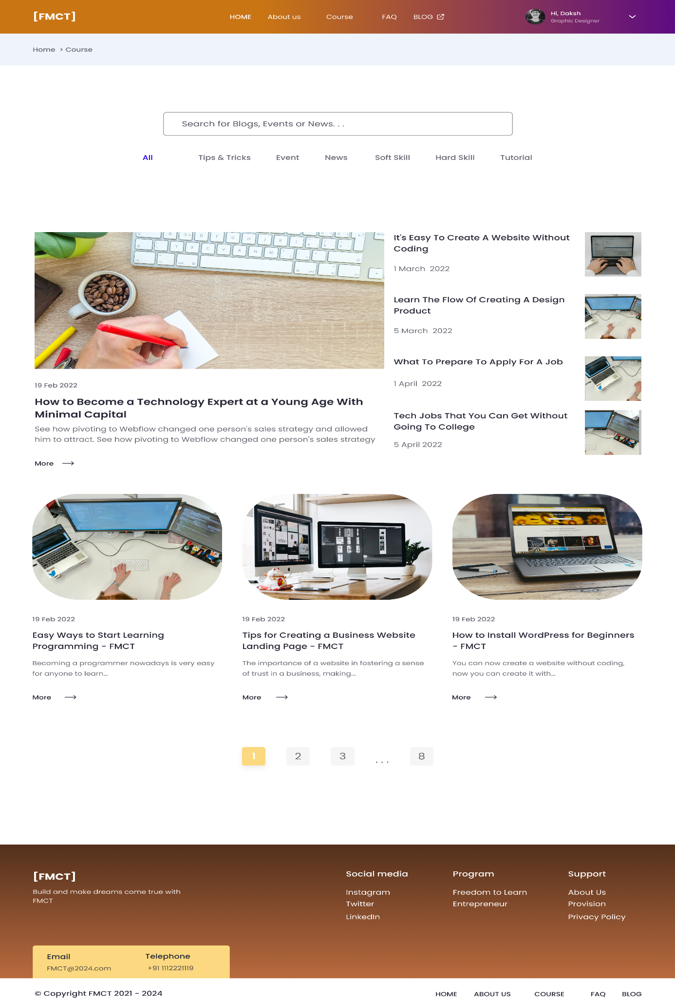

**Color Scheme**

**Primary Colors**:

* Gradient header and top navigation bar: Deep purple transitioning to orange (#6A1B9A to #FF6F00).

**Background:**

* Light greyish-blue (#F9FAFB) background for the main content area.

**Text:**

* Black for primary text (#000000).
* Grey for secondary text (#9E9E9E).

**Buttons and Highlights**:

* Yellow for the active page button in pagination.
* Blue for links and other interactive elements.

**Typography**

* Primary Font: Sans-serif, chosen for readability and modern aesthetics.
* Font Weight: Variation between normal, bold, and semi-bold to differentiate headings, subheadings, and body text.

**User Flow and Navigation**

**Header and Navigation Bar (Top)**

* Logo: FMCT logo on the left.

**Navigation Links:**

* Home
* About us
* Course
* FAQ
* Blog
* User Profile: Personalized greeting ("Hi, Daksh") with a small profile picture and dropdown for user settings.

**Search Bar and Category Filters (Below Header)**

* Search Bar: Centered and prominent, allowing users to search for blogs, events, or news.

**Category Filters:**

* "All", "Tips & Tricks", "Event", "News", "Soft Skill", "Hard Skill", "Tutorial" — allowing users to filter content based on interest.

**Main Content Area (Blog Listings)**

**Featured Blog Post:**

* Large image on the left with a title, date, and short description on the right.
* Example: "How to Become a Technology Expert at a Young Age With Minimal Capital".

**Recent Blog Posts (Right Sidebar):**

* List of recent posts with small thumbnails, titles, and dates.
* Example: "It's Easy To Create A Website Without Coding" (1 March 2022).

**Additional Blog Posts:**

* Grid layout with images, titles, dates, and short descriptions.
* Example: "Easy Ways to Start Learning Programming - FMCT" (19 Feb 2022).

**Pagination (Bottom of Main Content Area)**

* Page Numbers: Numbered buttons to navigate between pages, with the current page highlighted in yellow.

**Footer:**

* Contact Information:
* Email: FMCT@2024.com
* Telephone: +91 1112221119
* Social Media Links: Icons for Instagram, Twitter, LinkedIn.

**Programs and Support Links:**

* Freedom to Learn, Entrepreneur, About Us, Provision, Privacy Policy.

**Copyright Information:**

* "© Copyright FMCT 2021 - 2024".

**Explanations for User Flow and Navigation Decisions**

**Header and Navigation Bar:**

Consistency and Accessibility:

* The header remains consistent across different pages, providing easy access to main sections of the platform.
* The gradient color scheme not only looks modern but also makes the header visually distinct.

**User Profile:**

* Personalized greetings and profile settings enhance user engagement and personalization.

**Search Bar and Category Filters:**

**Search Functionality:**

* Centralized search bar allows users to quickly find specific content, improving user efficiency.

**Category Filters:**

* Filters help users narrow down content, making it easier to find relevant blog posts based on their interests.

**Main Content Area:**

**Featured Blog Post:**

* Highlighting a featured post at the top grabs user attention, showcasing important or popular content.

**Recent and Additional Blog Posts:**

* The layout with images and text previews helps users quickly scan and identify interesting posts.
* Dates and short descriptions provide context at a glance.

**Pagination:**

**Ease of Navigation:**

* Pagination at the bottom ensures users can navigate through multiple pages of content easily.
* Highlighted current page enhances usability by showing users their position.

**Footer:**

**Comprehensive Information:**

* Contact details, social media links, and additional resources are provided for user convenience.
* The footer’s presence on every page ensures users always have access to support and further information.

**Reasoning Behind Design Choices**

**Color Scheme:**

* The use of a gradient in the header ensures a modern and appealing look, while the light background keeps the content readable and the interface clean.

**Typography:**

* Poppins fonts and varying weights enhance readability and create a clear visual hierarchy.

**User Flow and Navigation:**

* Consistent navigation elements ensure users can easily move through the platform.
* The combination of search functionality and category filters makes it easy for users to find specific content quickly.
* Featuring important posts and a clear layout of additional posts help users engage with the content.
* Pagination and a comprehensive footer ensure users can navigate efficiently and always have access to necessary information.

**1.10 Detail Blog, Event**

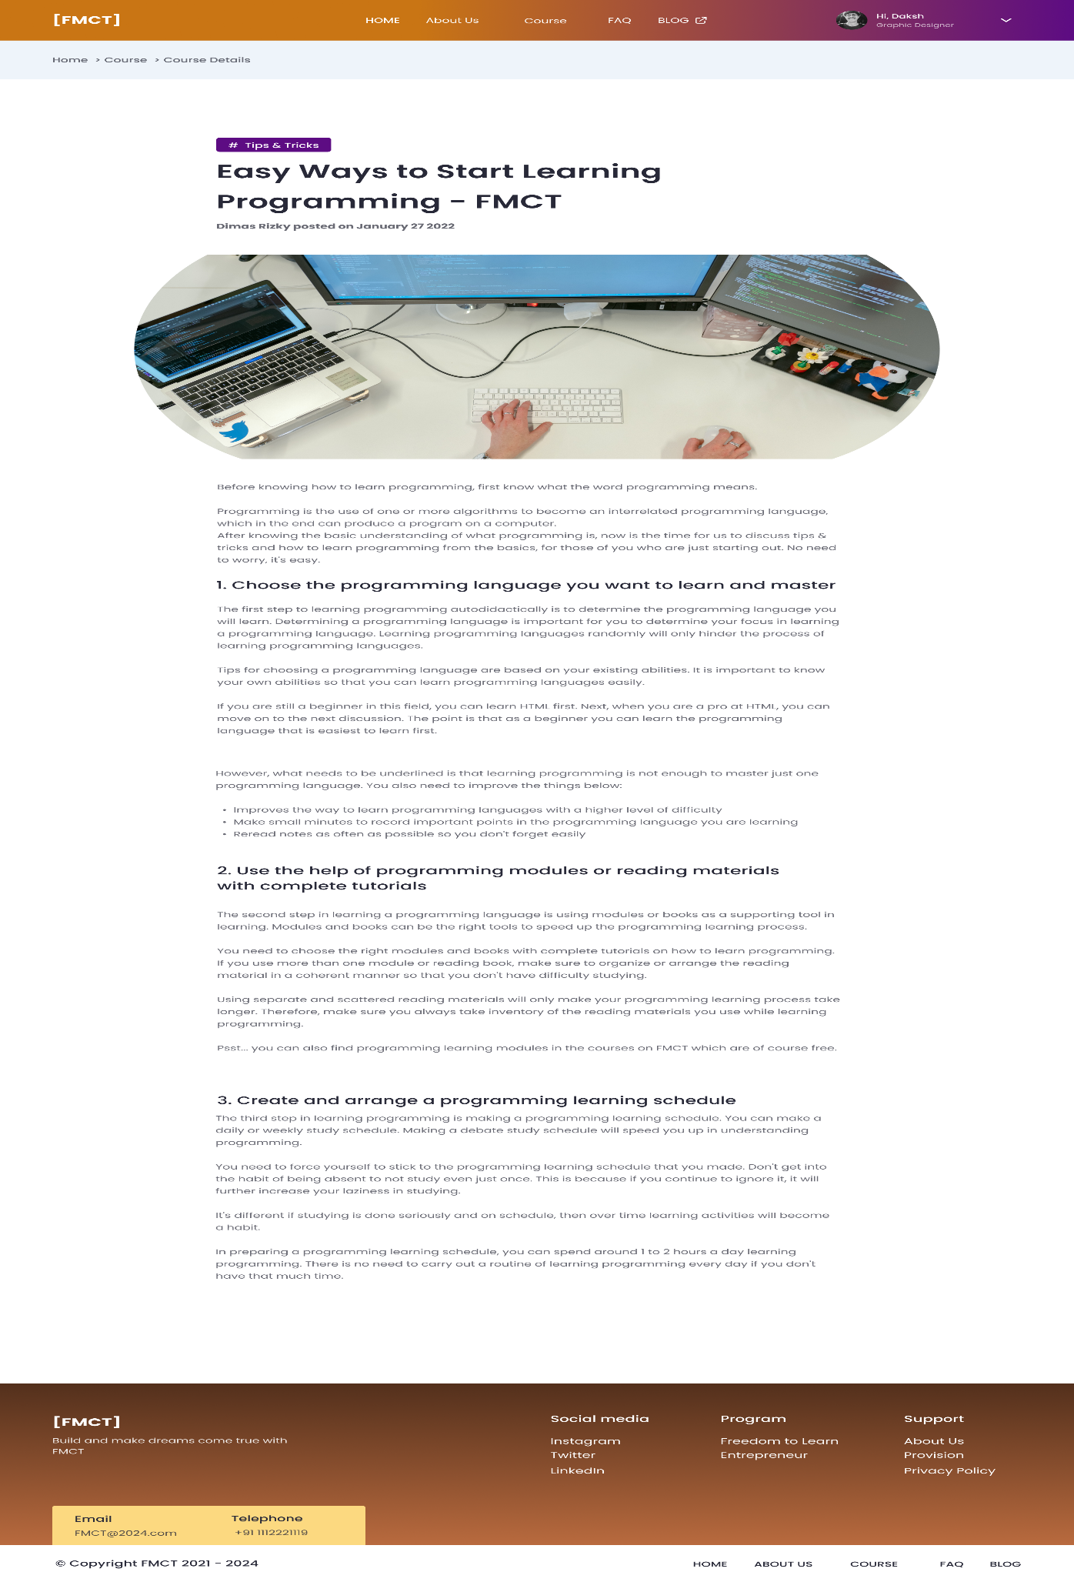

**Color Scheme**

**Primary Colors:**

* Gradient header and top navigation bar: Deep purple transitioning to orange (#C97514 to # 5D0C83).

**Background:**

* Light greyish blue (#EEF4FA) background for the main content area.

**Text:**

* Black for primary text (#000000).
* Grey for secondary text (#282938).

**Buttons and Highlights:**

* Yellow for the active page button in pagination and footer contact details.

**Typography**

* Primary Font: Poppins, chosen for readability and modern aesthetics.
* Font Weight: Variation between normal, bold, and semi-bold to differentiate headings, subheadings, and body text.

**User Flow and Navigation**

**Header and Navigation Bar (Top)**

* Logo: FMCT logo on the left.
* Navigation Links:
* Home
* About us
* Course
* FAQ
* Blog

**User Profile:**

* Personalized greeting ("Hi, Daksh") with a small profile picture and dropdown for user settings.

**Breadcrumb Navigation:**

* Path: "Home > Course > Course Details"
* Provides a clear path for users to understand their current location on the site and navigate back to previous sections easily.

**Blog Post Header:**

* Category Tag: "Tips & Tricks" in a purple box, indicating the category of the blog post.
* Title: Bold and prominent, "Easy Ways to Start Learning Programming – FMCT".
* Author and Date: Smaller font size, "Dimas Rizky posted on January 27 2022".
* Featured Image: Large image related to the blog post topic, visually engaging users.

**Main Content Area:**

**Blog Post Content:**

* Introduction: Introduction to the topic of learning programming.

**Sections with Headings:**

* Each section is clearly divided with numbered headings and subheadings for easy navigation and readability.
* Section 1: Choose the programming language you want to learn and master
* Section 2: Use the help of programming modules or reading materials with complete tutorials
* Section 3: Create and arrange a programming learning schedule
* Text: Well-structured paragraphs with important points highlighted for easy scanning.
* Lists: Bulleted lists for tips and important information to enhance readability.

**Footer:**

* Contact Information:
* Email: FMCT@2024.com
* Telephone: +91 1112221119
* Social Media Links: Icons for Instagram, Twitter, LinkedIn.
* Programs and Support Links:
* Freedom to Learn, Entrepreneur, About Us, Provision, Privacy Policy.
* Copyright Information:
* "© Copyright FMCT 2021 - 2024".

**Explanations for User Flow and Navigation Decisions**

**Header and Navigation Bar:**

**Consistency and Accessibility:**

* The header remains consistent across different pages, providing easy access to main sections of the platform.
* The gradient color scheme not only looks modern but also makes the header visually distinct.

**User Profile:**

* Personalized greetings and profile settings enhance user engagement and personalization.

**Breadcrumb Navigation:**

**Path Indication:**

* Breadcrumbs provide a clear navigation path, allowing users to easily trace their steps back to the home page or previous sections. This improves usability and helps users understand their current location on the site.

**Blog Post Header:**

**Category Tag:**

* The category tag helps users immediately understand the type of content they are about to read, enhancing content discoverability.

**Title and Author Information:**

* A prominent title grabs user attention, while author and date information provide context and credibility to the content.

**Featured Image:**

* A large, relevant image makes the page visually engaging and provides a preview of the content.

**Main Content Area:**

**Content Structure:**

* Clearly divided sections with headings and subheadings make the content easy to navigate and read. Numbered sections guide the reader through a logical progression of ideas.

**Lists and Bullet Points:**

* Using lists and bullet points to highlight key information ensures that readers can quickly scan and absorb important points, improving the overall readability of the content.

**Footer:**

**Comprehensive Information:**

* Contact details, social media links, and additional resources are provided for user convenience.
* The footer’s presence on every page ensures users always have access to support and further information.

**Reasoning Behind Design Choices**

**Color Scheme:**

* The use of a gradient in the header ensures a modern and appealing look, while the light background keeps the content readable and the interface clean.

**Typography:**

* Poppins fonts and varying weights enhance readability and create a clear visual hierarchy.

**User Flow and Navigation:**

* Consistent navigation elements ensure users can easily move through the platform.
* The combination of search functionality and category filters makes it easy for users to find specific content quickly.
* Featuring important posts and a clear layout of additional posts help users engage with the content.
* Pagination and a comprehensive footer ensure users can navigate efficiently and have access to necessary information at all times.
  1. **404**

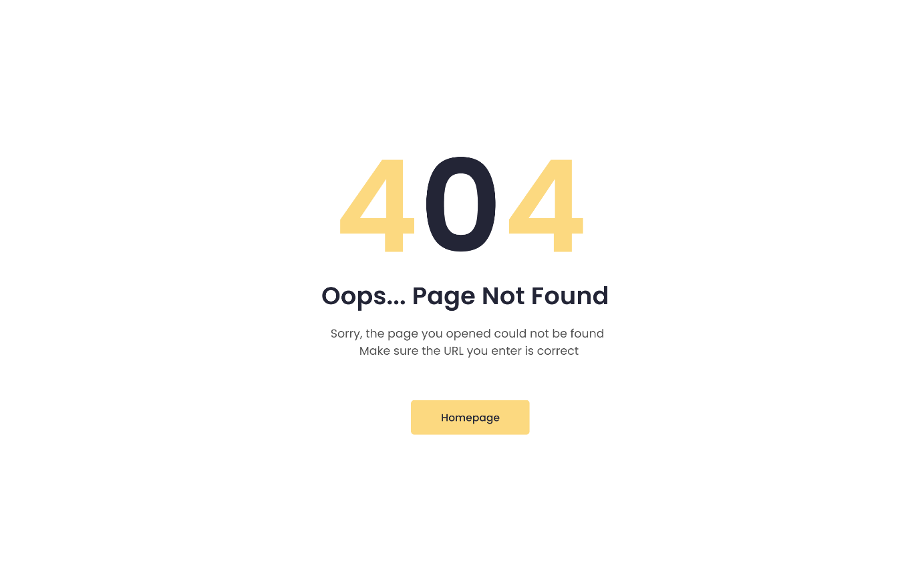

**Color Code:**

* Background Color: White (#FFFFFF)
* Primary Text Color: Dark Blue (#232536)
* Highlight Color: Light Yellow (#FCD980)
* Button Background Color: Light Yellow (#FCD980)
* Button Text Color: Dark Blue (#232536)

**Typography:**

* Main Error Code ("404"): Large, bold font in Light Yellow (#FCD980)
* Error Message ("Oops... Page Not Found"): Medium-sized, bold font in Dark Blue (#232536)
* Detailed Explanation ("Sorry, the page you opened could not be found. Make sure the URL you enter is correct"): Small, regular font in Dark Blue (#232536)
* Button Text ("Homepage"): Regular font in Dark Blue (#232536)

**Layout:**

* Centered Alignment: All text and the button are centrally aligned both vertically and horizontally.
* Spacing: Adequate spacing between the main error code, the error message, the detailed explanation, and the button to ensure clarity and readability.

**Explanations for User Flow and Navigation Decisions:**

**Centered Alignment:**

* Central alignment is chosen to immediately grab the user's attention. When a user lands on a 404 page, they need clear, quick information on what went wrong and what to do next. Centring the content ensures that it is the first thing the user sees.

**Color Contrast:**

* The high contrast between the background (white) and the text (dark blue) ensures readability. The use of light yellow for the main error code and the button provides a visual hierarchy, guiding the user's eyes to the most critical parts of the page.

**Clear Messaging:**

* The phrase "Oops... Page Not Found" is friendly and approachable, reducing user frustration. The subsequent explanation provides a straightforward reason for the error, which helps manage user expectations and reduces confusion.

**Call-to-Action (CTA) Button:**

* The "Homepage" button is prominently displayed and easily accessible. This provides a clear next step for the user, reducing the chances of them leaving the site altogether. Redirecting users to the homepage is a common practice to retain user engagement.

**Minimal Design:**

* The minimalistic design helps in focusing the user's attention on the error message and the call-to-action button without unnecessary distractions. This enhances the user experience by providing essential information quickly and effectively.

**Reasoning:**

* User Experience (UX): The design decisions prioritize a seamless and frustration-free user experience. The goal is to quickly inform the user of the error and provide an easy way to continue navigating the site.
* Readability and Accessibility: High contrast and clear typography ensure that the message is readable for all users, including those with visual impairments.
* Engagement Retention: By providing a clear path back to the homepage, the design aims to retain user engagement and prevent users from leaving the site.

**Overview of project 1 prototype**

